**UNIT-IV**

**Cross Functional Information System**

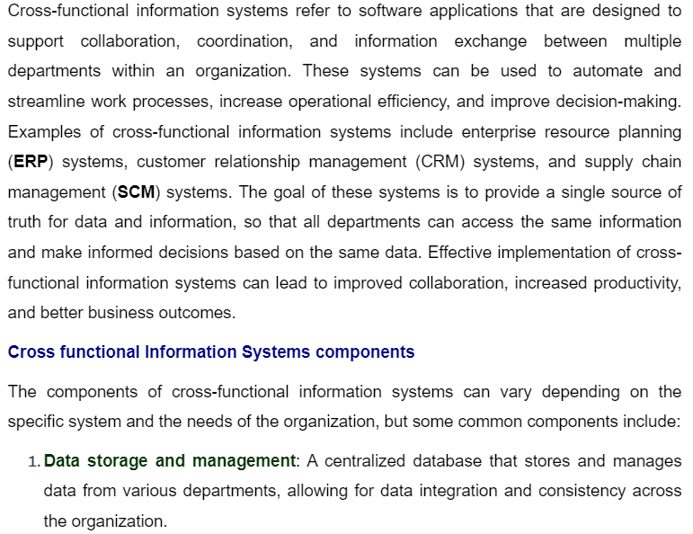

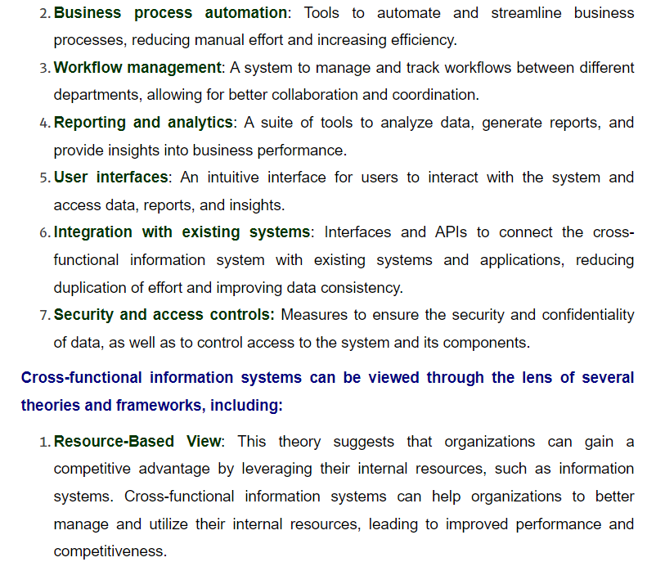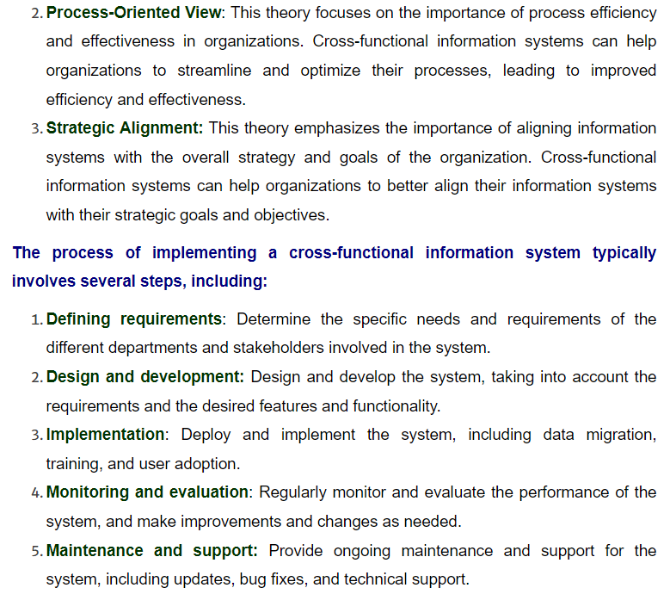

**Cross Functional Information System Uses:**

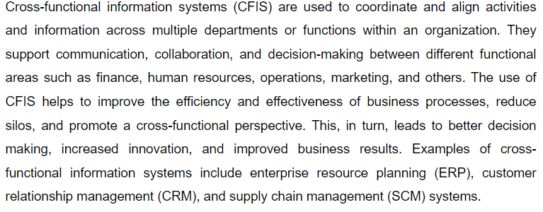

**What is HRIS?**

A human resource information system (HRIS) is software that provides a centralized repository of employee master data that the human resource management ([HRM](https://www.techtarget.com/searchhrsoftware/definition/human-resource-management-HRM)) group needs for completing core human resource ([core HR](https://www.techtarget.com/searchhrsoftware/definition/core-HR-core-human-resources)) processes. An HRIS can help HR and organizations become more efficient through the use of technology.

An HRIS stores, processes and manages employee data, such as names, addresses, national IDs or Social Security numbers, visa or work permit information, and information about dependents. It typically also provides HR functions such as [recruiting](https://www.techtarget.com/searchhrsoftware/definition/recruiter), applicant tracking, time and attendance management, performance appraisals and [benefits administration](https://www.techtarget.com/searchhrsoftware/definition/benefits-administration). It may also offer [employee self-service](https://www.techtarget.com/searchhrsoftware/definition/employee-self-service) functions, and perhaps even accounting functions.

In some ways, an HRIS can be considered a smart database of employee information. The interaction of the data, the processes that can be performed and the reporting capabilities make the data stored in the system [more accessible and usable](https://www.techtarget.com/searchhrsoftware/podcast/HRIS-department-an-essential-bridge-between-HR-IT).

**HRIS benefits**

HRIS software can breathe new life into a company's HR processes and procedures. While the benefits may vary depending on the system a company opts for or the modules they choose, the following are the key benefits of HRIS software:

* **Expedites tasks.** An HRIS enables the HR department to spend less time on clerical tasks, helps ensure the accuracy of employee data and can make it easier for employees to manage their information.
* **Reduces paperwork.** Having a centralized [repository](https://www.techtarget.com/searchoracle/definition/repository) for employee data removes the need for  storing paper files, which can be easily damaged, as well as the need to search through large paper-based employee files to find information.
* **Simplifies predictive analysis and visualizations.** Depending on the type of HRIS software, it may generate various reports, provide [ad hoc](https://www.techtarget.com/whatis/definition/ad-hoc) reporting capabilities and offer [HR analytics](https://www.techtarget.com/searchhrsoftware/definition/human-resources-analytics-talent-analytics) on important metrics such as headcount and turnover. Modern HRIS software also offers visualization capabilities for employee data, such as automatically rendered organizational charts or [nine-box grids](https://www.techtarget.com/searchhrsoftware/definition/nine-box-grid).
* **Empowers employees.**Employees can directly access and make changes to their personal information without the need to contact HR.
* **Improves productivity.** When an HRIS offers employee or manager self-service, the process for making employee master data or organizational changes becomes more efficient and uses less time than paper-based requests. Approval [workflows](https://www.techtarget.com/searchcio/definition/workflow) enable changes to be approved or rejected, with the necessary individuals automatically notified. An HRIS might also offer mobile capabilities that extend self-service and provide additional flexibility for remote workers.
* **Maintains compliance.**HR tasks are highly regulated and there's little to no margin for error. Many HRIS programs have monitoring capabilities and are designed with specific compliance regulations in mind. This encourages organizations to stay compliant and avoid legal issues, penalties and financial losses.
* **Offers security and privacy.** An HRIS also helps secure employee data and keep information private. When using paper forms or [spreadsheets](https://www.techtarget.com/whatis/definition/spreadsheet), information can easily be accessed by people who may not have the authority to access it. An HRIS can secure information so that it can only be accessed by authorized individuals. Data security and privacy are important factors when handling sensitive personal information, especially in countries such as Germany and France, where works councils have a strong role in protecting employee data. With the exception of a lock and key, protecting paper records can be extremely difficult.

### Types of HRIS software

[A variety of HRIS software is available](https://www.techtarget.com/searchhrsoftware/How-to-choose-an-HR-software-system) and aimed at different types of customers, ranging from small and medium-sized businesses ([SMBs](https://www.techtarget.com/whatis/definition/SMB-small-and-medium-sized-business-or-small-and-midsized-business)) all the way up to large enterprises. Usually, the difference is in the range and depth of features for each process area.

While most HRIS software covers a large portion of the processes described above, many HRISes aimed at midmarket enterprises have less depth of functionality in each feature than those aimed at large enterprises.

In this way, the HRIS market is similar to the automobile market. All automobiles will get a driver from A to B, but major differences exist in the quality and amenities offered.

### HRIS functions

As an HR tool, an HRIS usually features modules to handle the following tasks:

* master data management ([MDM](https://www.techtarget.com/searchdatamanagement/definition/master-data-management));
* organizational management, such as positions and departments;
* employee and manager self-services;
* absence and leave management;
* benefits administration;
* workflows;
* performance appraisals;
* recruiting and applicant tracking;
* [compensation management](https://www.techtarget.com/searchhrsoftware/definition/compensation-management);
* training tracking as opposed to a learning management system ([LMS](https://www.techtarget.com/searchcio/definition/learning-management-system)) and organizational development; and
* reporting and basic analytics.

An HRIS provides a comprehensive set of functionalities to serve most HR needs. Without this, unsecured or paper-based documents or spreadsheets are required to store data. Manual data entry can cause errors, and manual cross-checking of documents and spreadsheets can be time-consuming and sometimes confusing, especially with a lack of standardization on how data is captured and stored.

Even when a specific system is purchased to cover a process -- such as benefits administration -- it may mean [manually entering employee data changes](https://www.techtarget.com/searchhrsoftware/tip/Why-an-HR-IT-interface-discussion-is-critical-to-implementation) to keep the system up to date. If multiple systems are used, data re-entry may be required for each system, or users may need to export data from one system, change it and then import it into another system.

In some instances, payroll can be part of an HRIS. However, many vendors either don't have payroll as part of their HRIS offering or -- as with Oracle, [Workday](https://www.techtarget.com/searchhrsoftware/definition/Workday) and [SAP](https://www.techtarget.com/searchsap/definition/SAP-SuccessFactors)

What is a marketing information system?

A marketing information system, or an MIS, is a system for gathering, storing, analyzing and distributing valuable marketing data to help marketers make better decisions. The input of a marketing information system focuses on collecting relevant internal and external data to analyze and interpret. The output of a marketing information system relates to distributing the findings to all essential internal marketing team members and managers. Marketers can then use the data to make more informed marketing decisions to promote the success of the business.

A marketing information system can be beneficial for multiple types of marketing decisions, such as:

* Control decisions: Middle-level marketing manager decisions related to corrective actions based on deviation from strategic plans implemented by higher-level marketing managers
* Operational decisions: Decisions related to the day-to-day activities of marketing professionals, especially related to accomplishing specific tasks
* Strategic decisions: High-level marketing manager decisions about matters that affect the entire organization, such as organizational policies, objectives and structure

**Types of data in a marketing information system**

Marketing information systems handle different types from multiple sources. The common types of data in a data marketing system are:

* Acquired databases

Databases often store large amounts of marketing and sales data and customer information, and some companies may purchase access to these databases for little to no cost. Businesses may enter the data they purchase into their marketing information system to help them make better, more informed decisions. For example, there are companies that specialize in gathering data related to business trends and consumer behavior and business trends and generating reports to sell. Similarly, companies may purchase information from government databases to learn about the demographic or economic information of companies, groups or specific individuals.

* Internal company data

Marketing information systems allow you to turn internal company data into valuable insights. For example, you may input data related to marketing activities or sales to generate reports. Also, you may integrate your marketing information system with an internal company communications network or intranet to gather information about certain employees, departments or business units.

* Marketing intelligence

Marketing information systems allow you to gain insights from the marketing intelligence data you gather about your target market. For example, explore options to gather marketing intelligence data from your competitors' websites or industry trade publications. You may also explore options that are less automated and more manual, such as talking with distributors, making observations, attending trade shows or testing products.

* Marketing research

Marketing information systems allow you to integrate the marketing research and data you gather from custom and syndicated research reports and primary or secondary research. It's important to find as much specific and unique information as possible, especially regarding your customers, competitors and overall business environment. This will help you gain more valuable insights to make better decisions.

**Why is it important to use a marketing information system?**

A marketing information system ensures efficient communication within an organization. It provides team members with reliable and valuable information to keep all internal teams informed and focused on specific tasks and goals. This can also help prevent miscommunication by providing everyone with the same access to shared information.

Using a marketing information system can also foster the overall success of your organization. By using well-organized data and analyzing and interpreting it, you may make better, more strategic decisions. You may also identify new ways to upgrade or expand your systems to further collect and analyze data to build a more efficient business.

Marketing information system process

Marketing information systems use a sequential process to synthesize data and share findings to influence decision-making. Here are the steps of the marketing information system process:

1. Determine the appropriate marketing metrics.
2. Gather relevant data from external and internal sources.
3. Graph the data to visualize trends.
4. Distribute the trend information to the appropriate departments.
5. Use the data to determine the right course of action to take.

Components of a marketing information system

Marketing information systems combine various data collection, processing, analysis and reporting capabilities to streamline marketing activities and influence decision-making. Each system contains four main components, which are:

Internal reports

Internal reports or records include the data from within the company. Referencing this data can provide you with valuable insights, particularly regarding a company's capabilities, successes and opportunities for improvement. Some examples of data internal reports may include are:

* Cash flows
* Inventories
* Marketing personnel costs
* Payables
* Product costs
* Receivables
* Sales records
* Stocks

Marketing data support systems

A marketing data support system includes the software programs and tools companies may use to collect, organize and analyze data. A system may include multiple applications or tools to include specific tools for specific tasks. As the programs work together, the system provides the core for how the marketing information system functions.

Marketing intelligence

Marketing intelligence refers to the data or information from external sources, such as industry associations or trade journals. It includes data related to the general marketing environment outside of the organization and the specific data within the market. Leveraging this information helps the company better understand their specific marketing and competitors within the market. Some examples of what marketing intelligence may include are:

* Changes in customer preferences and tastes
* Competitors' pricing strategies
* Competitors' promotion strategies
* Marketing trends
* New products in the market